**What is Azure Service Fabric?**

Azure Service Fabric is a distributed systems platform that makes it easy to package, deploy, and manage scalable and reliable microservices and containers

- enables you to build and manage scalable and reliable applications composed of microservices

- Services runs at high density on a shared pool of machines called as cluster

- provides a sophisticated, lightweight runtime to build microservices running in containers

- Microservices are distributed, scalable, stateless, and stateful.

**Features of Service Fabric**

* Applications composed of microservices
* Container deployment and orchestration
* Any OS, any cloud
* Stateless and stateful microservices for Service Fabric
* Application lifecycle management

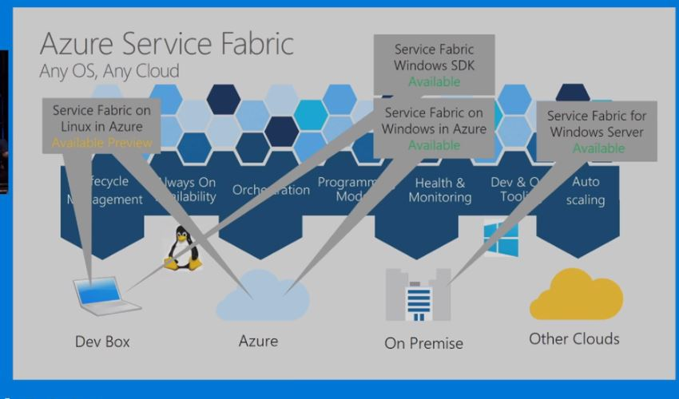

**Service Fabric Consist –**

**Code Packages**

Exe

dependencies.dll

**Config Packages**

Xml/yml files

Json file

**Service packge**

nodes

Containers

**Service Fabric programming model overview**

Service Fabric offers multiple ways to write and manage your services.

offers multiple ways to write and manage your services

Programming models Provided by Service Fabric -

**1. Guest executables**

simple executable (written in any language) that can be run as a service

Services uses the Service Fabric APIs

**2. Reliable Services**

Reliable Services is a light-weight framework for writing services that integrate with the Service Fabric platform and benefit from the full set of platform features

Reliable Services can be stateless or statefull

**3. ASP.NET Core**

ASP.NET Core is a new open-source and cross-platform framework for building modern cloud-based Internet-connected applications, such as web apps, IoT apps, and mobile backends

**4. Reliable Actors**

Reliable Actors is a Service Fabric application framework based on the Virtual Actor pattern.

An actor is an isolated, independent unit of compute and state with single-threaded execution.

**5. Containers**

Service Fabric can also deploy services in containers.

Service Fabric supports deployment of Linux containers and Windows containers on Windows Server 2016

Service Fabric can also deploy services in containers. Service Fabric supports deployment of Linux containers and Windows containers on Windows Server 2016

